**G.Harish**

**192011095**

**USING RAPTOR – CALCULATE FIBONACCI SERIES**

**FLOWCHART**

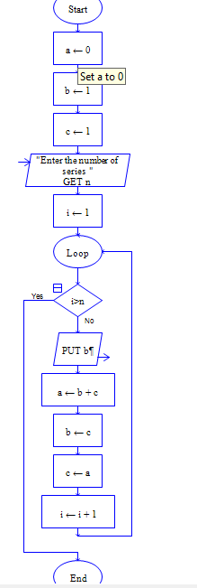

**OUTPUT**

INPUT IS 9

